IMPROVEMENT OF STUDENTS’ UNDERSTANDING OF ALGEBRA OF SETS AND VENN-DIAGRAMS
Ludwig Paditz
Dresden University of Applied Sciences, Faculty of Information Technology and Mathematics
paditz@informatik.htw-dresden.de

The basics of set theory consists in sets, elements, lists, set-builder notation, subsets, equal sets, the empty set, union, intersection, difference, symmetric difference and Cartesian product and power sets. Sets are one of the most fundamental concepts in mathematics but we can’t calculate with set operations and set relations on any calculators, e.g. on the ClassPad. On the other hand we can write in the text mode with special symbols of the set theory in the ClassPad, e.g. ∈, ∉, ∪, ∩ , \ , ⊂ , ⊆ , ≠ , …. Thus some students of informatics tried to introduce the set theory in the operating system. They followed two ways of solution: 1. Create a so called AddIn for ClassPad330 to calculate with sets of real numbers and 2. Create a Basic-program for ClassPad400 to calculate with finite sets of numbers or words. For the visualizing we get Venn-diagrams for a basic set Ω and up to four subsets A, B, C, D of Ω. An important application consists in the basics of probability theory if the sets are random events.

1. INTRODUCTION
In the mathematics these days essentially everything is a set. Some knowledge of the set theory is a necessary part of the background everyone needs for the further study of mathematics. We want to review here elementary-school set theory and the algebra of sets. Finally we will use the calculator to compute and draw Venn-diagrams. A set is a collection of things (called its members or elements), e.g. the set of the prime numbers less 10: A={2,3,5,7} or the set B of all real solutions of the polynomial equation x⁴-17x³+101x²-247x+210=0, i.e. B=A. B and A were defined in different ways. Let be ∅ = {x| x ≠ x} the empty set. We can form the set {∅} and {{∅}} and finally {∅,{∅},{{∅}}}. The last is a three element set. Two other familiar operations on sets are the union and intersection. For example {x,y}∪{z}={x,y,z} or {2,3,5,7}∩{1,2,3,4}={2,3}. Any set A will have one or more subsets. In fact if A has n elements than A has 2^{n} subsets. We can gather all of the subsets of A into one collection called the power set of A. For example the power set of {0,1} is {∅,{0},{1},{0,1}} and the power set of ∅ is {∅} and the power set of {∅} is {∅,{∅}}.
In the new created AddIn “Real Sets” for ClassPad330 we use the set-builder notation {x|…}, e.g. {x|a<x<b} or {x|x≥c} or {x|x=2∧x=3∧x=5}={x|2,3,5}. In a second new AddIn “Venn-Diagr…” for finite sets we use the notation {2,3,5}. Here the sets will be created by the help of the sequence command or by the help of random numbers. The output is a Venn-diagram. In the third solution of calculation and visualization in the set theory (the basic-program StrOVenn for set theory for ClassPad400) we use the string notation “{2,3,5}” or “{x1,x2,x3}” or “{(a,b),(a,c),(2,c),(d,4)}” or “{Anna, Max, Lutz, Tanja}”, i.e. we can work with finite sets of any kind. In the following parts we will demonstrate some examples with the CAS-calculator ClassPad. For all programs a PC-emulator exists.

2. THE ADDIN “REAL SETS” FOR CLASSPAD330
The students wrote a program in C⁺⁺ and used than the CASIO-SDK (software development kid) to compile the source program into a ClassPad AddIn. The AddIn can be installed in a handheld calculator but not in the PC-manager-software. Thus the students compiled their program additional in an exe-file, which runs on a Windows-PC (Real_Sets.exe). Here we need additional a special library, the ClassPadDLLgcc.dll, in the exe-folder.

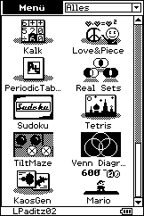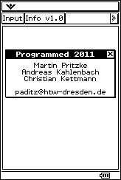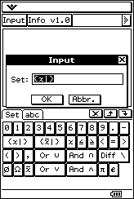
The new Real Sets-Icon in the menu. The students created a special keyboard for the set theory!

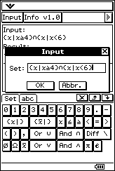 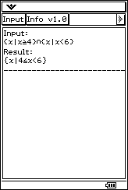 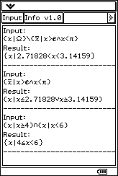 The output window.
For the empty set here we have the symbol ∅ and the full set is Ω (all real numbers). Additional we can calculate the complementary set in Ω by the help of the x-bar notation. We can use brackets (…) for multiple operations, e.g. A∩(B∪C). Sometimes we get an error message, e.g. we forgot x after | {x|<4} yields error “Failure”: wrong Input! Position: 4. Such messages are part of the created AddIn.

3. THE ADDIN “VENN-DIAGR…” FOR CLASSPAD330
Another student created an AddIn to draw Venn-diagrams for one, two or three subsets in Ω.
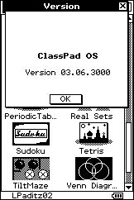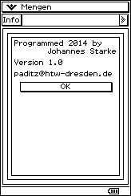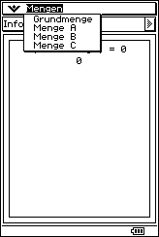
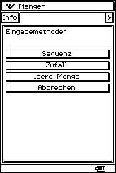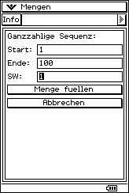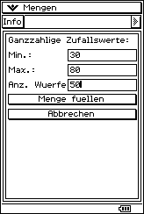
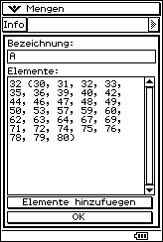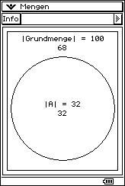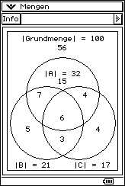

4. THE PROGRAM “STROVENN” FOR CLASSPAD400
The program StrOVenn works with sets, which are String-variables. The Output is a Venn-diagram. Therefore the program is named StrOVenn. The syntax of the input is
StrOVenn(Ω,A,B,C,D,4,2,1) or StrOVenn(Ω,A,B,C,dummy,3,2,1) or
StrOVenn(Ω,A,B,dummy,dummy,2,2,1).
The last parameter 1 describes the type of data: numeric or alpha-numeric sets. Later the parameter 0 in the last position should be for the single type: numeric sets. Finally the fixed parameter 2 stands for a color Venn-diagram (ClassPad400) or 1 for a black/white diagram (ClassPad330).
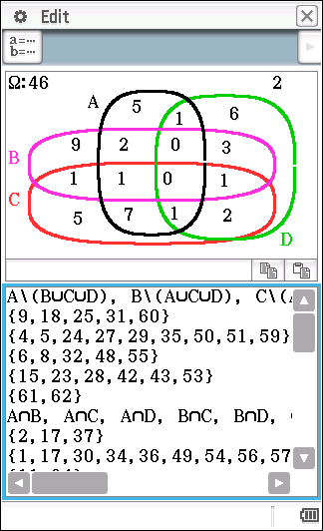 Venn-diagram with 16 disjunct fields and cardinal numbers.

5. DISCUSSION

The mentioned AddIns or the program on set theory should support the learning process and serve for a better understanding some problems in set theory and in several applications of set theory, e.g. in the basics of probability theory. Thus (see the picture above) the set A\(B∪C∪D) contains 5 elements and the probability P of A\(B∪C∪D) in Ω is 5/46. Additional we see that A\(B∪C∪D) is {9,18,25,31,60}.

References
Barr, S. (1964, reprint 1989). Experiments in Topology. New York: Dover Publications.
Enderton, H. B. (1977). Elements of set theory. New York - San Francisco - London: Academic Press.
Paditz, L. (2011). The basics of set theory – some new possibilities with ClassPad. International Conference on Turning Dreams into Reality: Transformations and Paradigm Shifts in Mathematics Education, Sep 11th - 17th, 2011, Rhodes University Grahamstown (South Africa) - Proceedings p. 254-260, URN: http://nbn-resolving.de/urn:nbn:de:bsz:14-qucosa-82943
Wallisch, F. (2015). mp4-video of a student: “Testdurchlauf-vierMengen” http://www.informatik.htw-dresden.de/~paditz/Testdurchlauf-vierMengen.mp4

